**CSS - Button gradient**

Kowshik, a lecturer known for his effective lecturing that are concise and intelligible was invited for a guest lecture at Linka University. One of the main concepts that he had to cover in his lecture topic "CSS properties" is about the gradient property which represents the transition between two or more colors.  
  
As Kowshik wanted to illustrate to the students the practical applications of the theory presented by him, he set off with the task of visually representing the types of styles applicable for the buttons using the gradient property. He requests your help to create a web page with the button of different styling using the linear gradient property.

**Hints :**

**Property button gradient**

CSS gradients let you display smooth transitions between two or more specified colors.

The transitions may be from left to right ,top to bottom and even diagonally.

Syntax :

background: linear-gradient(direction, color-stop1, color-stop2, ...); direction may be 'to right', 'to left' or even empty.

**Constraints :**  
button tag must be used inside the html page  
Tag 'button' must be present 10 times inside the html page.  
The Content in the tags should be the same as given in the problem content.  
        height 50px  
        width 95px  
        background linear-gradient(#ef3055,#a90d2c)  
        for first button  
  
        height 50px  
        width 90px  
        background linear-gradient(#edbb99,#e59866)  
        for second button  
          
        height 50px  
        width 85px  
        background linear-gradient(#cded19,#72840a)  
        for third button  
            
        height 50px  
        width 80px  
        background linear-gradient(#20d6b5,#187665)  
        for forth button  
      
        height 45px  
        width 75px  
        background linear-gradient(#f9e79f,#d6d317)  
        for fifth button  
          
        height 40px  
        width 70px  
        background linear-gradient(#d1f2eb,#15cab1)  
        for sixth button  
      
        height 35px  
        width 65px  
        background linear-gradient(#d6eaf8,#13a5b9)  
        for seventh button  
  
        height 30px  
        width 65px  
        background linear-gradient(#d2b4de,#6611cc)  
        for eighth button  
      
        height 25px  
        width 70px  
        background linear-gradient(#d7bde2,#884ea0)  
        for ninth button  
           
        height 20px  
        width 75px  
        background linear-gradient(#52be80,#1e8449)  
        for tenth button  
  
**Note :**   
Content of the page should be present as shown in the screenshot.  
Kindly refer the content which is given as a part of description.  
  
**Sample Screenshot 1 :**  
  
**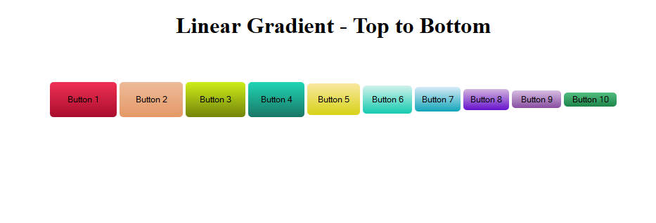  
  
Sample Screenshot 2 :  
  
